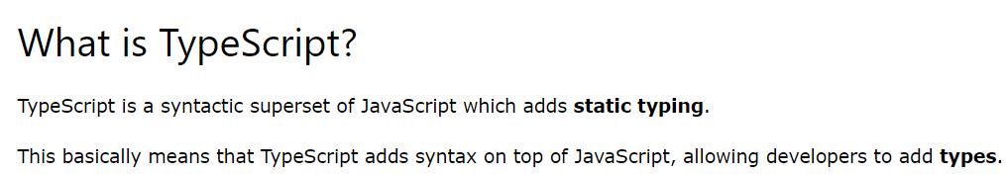

It was developed by Microsoft to overcome the shortcomings of Javascript

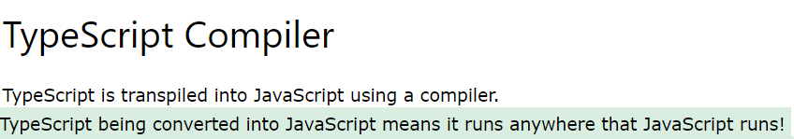

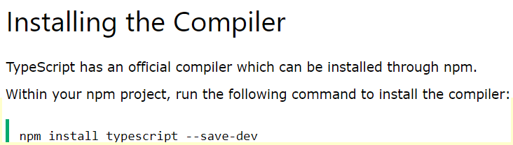



Print data to Console



To run the Code we use tsc script.ts

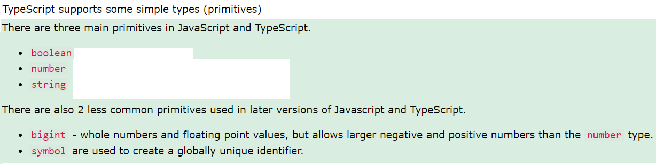

Examples-

Constants are declared using “const”

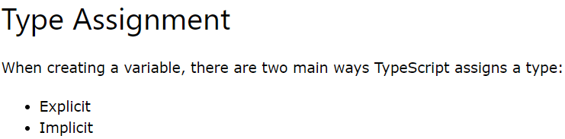

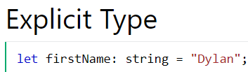

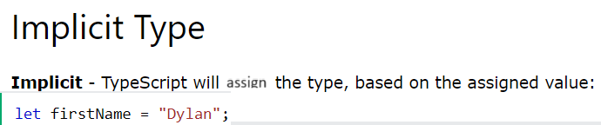

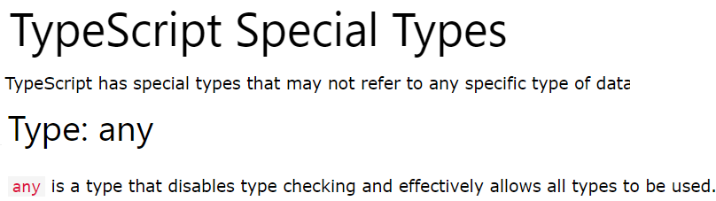



If Datatype is not specified for a variable it gets assigned to “any” type

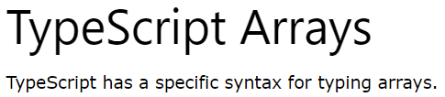

Ex-



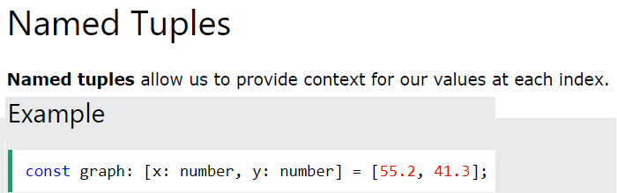

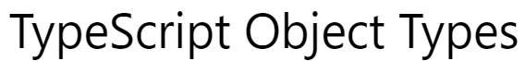

To pass null values to functions we use the below code

For loop-



Ex-

async vs sync-

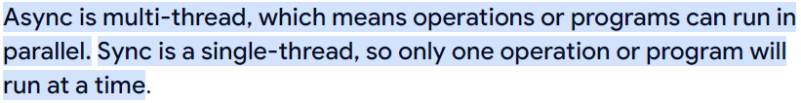



async/await-



Ex-

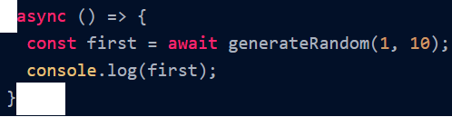



Syntax-

Ex-

Consider pet.js

// 📂 Pet.js

export class VirtualPet {

constructor(name, species) {

this.name = name;

this.species = species;

this.energy = 100;

}

// Play with the pet

play() {

this.energy -= 10;

this._checkStats();

}

// Feed the pet

feed() {

this.energy += 20;

this._checkStats();

}

// Private method to check and limit the stats

_checkStats() {

if (this.energy > 100) {

this.energy = 100;

}

if (this.energy < 0) {

this.energy = 0;

}

}

// Get the pet's status

getStatus() {

return `${this.name} the ${this.species} - Energy: ${this.energy}`;

}

}

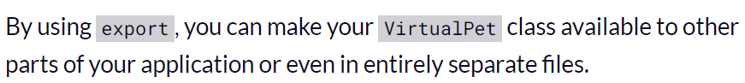

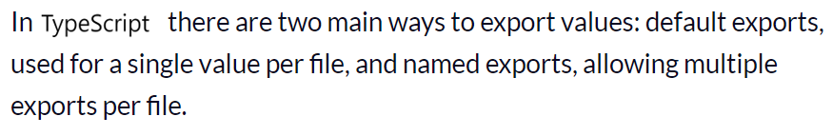





Ex-

Namespace-



Interface-



Matchers Interface-



Handling JSON files-

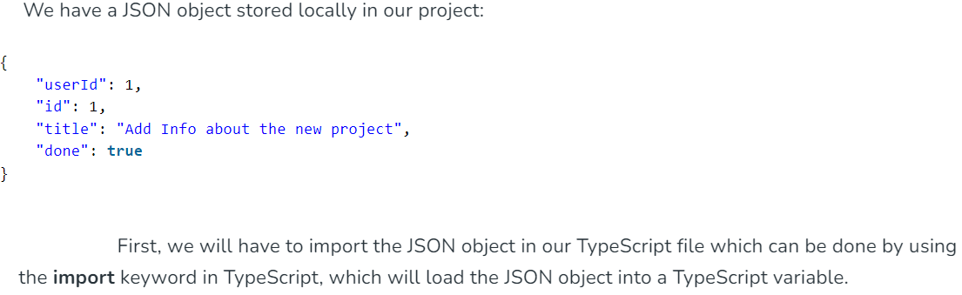

Ex-



Sample script-



